PROJECT REPORT
Flashcard Learning System in C Programming

1. Title of the Project
Flashcard Learning System
Title Page
Course: Programming in C
Submitted By: __SHAGUN MER_____
Roll Number: ___590027223_____
Academic Year: 2025-26

2. Introduction
Learning and revision become easier when information is organized in compact question-answer form, similar to traditional flashcards. This project implements a digital Flashcard Learning System using the C programming language.
The system allows users to:
- Add new flashcards
- View stored flashcards
- Search flashcards by keyword
- Take a quiz mode
- Delete flashcards
- Save and load data from a file
This project demonstrates data structures, file handling, user-defined functions, pointers, and modular programming in C.

3. Objectives
- To store educational content in an organized question-answer format.
- To build a user-friendly console-based learning tool.
- To explore file handling, arrays, structs, and functions in C.
- To provide a revision and testing mode for learners.

4. Scope of the Project
The Flashcard Learning System is useful for:
- Students preparing for exams
- Teachers creating study material
- Self-learners who need quick revision tools
- Competitive exam preparation (MCQs, definitions, formulas)
Future scope includes encrypted storage, multiple users, shuffle quiz mode, and UI upgrades.

5. Software & Hardware Requirements
Category | Requirement
Programming Language | C
Compiler | GCC / Turbo C / CodeBlocks / Dev-C++
RAM | Minimum 2 GB
OS | Windows / Linux / MacOS

6. System Design
6.1 Flowchart

7. Program Code
Already provided by you — attach the final updated version in this section.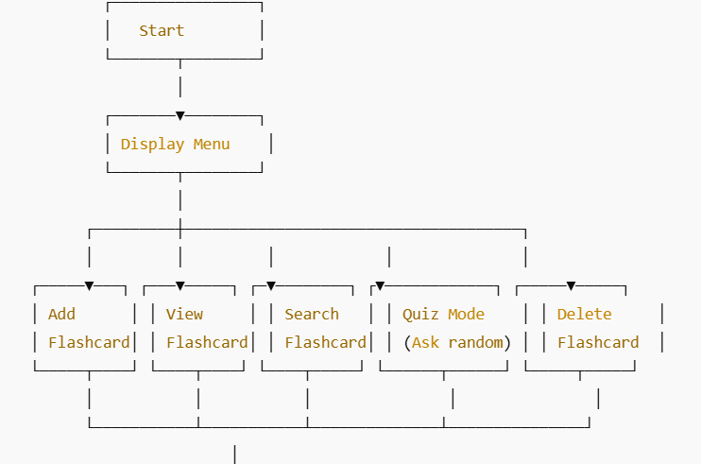

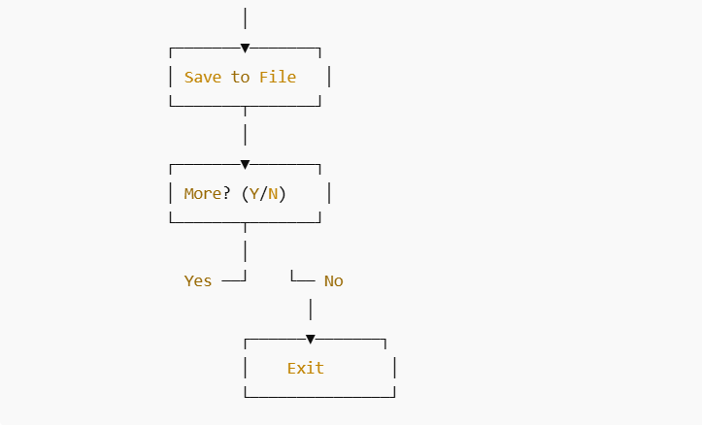
8. Sample Output Screenshots
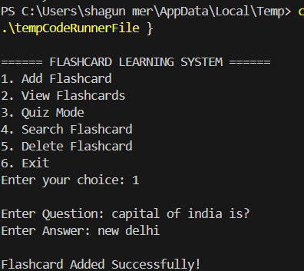
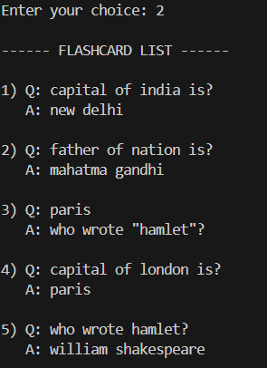

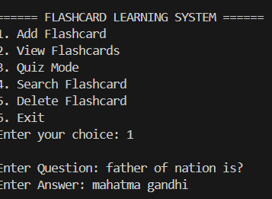
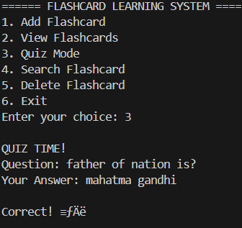
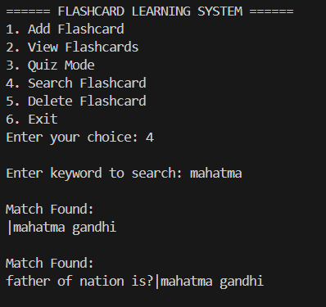
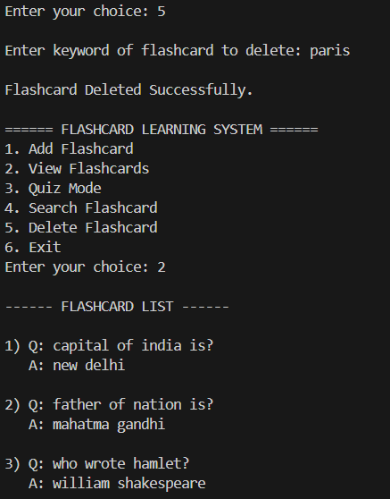
9. Testing & Validation
Test Case | Input | Expected Output | Result
Adding flashcard | Question + Answer | "Saved Successfully" | Pass
Searching keyword | "Math" | Returns related flashcards | Pass
Quiz Mode | User Answers | Shows correct/incorrect feedback | Pass

10. Applications
- Revision tool for school/college students
- Vocabulary learning
- Language flashcards
- Coding concept memory system
- Exam preparation

11. Advantages
- Simple and easy to use
- Data remains saved between sessions
- Provides revision and testing modes
- Portable and storage-efficient

12. Limitations
- Console-based interface
- No data encryption
- No user accounts or progress tracking

13. Future Enhancements
- Export to PDF
- Shuffle mode and timer quizzes
- GUI using GTK or Web-based extension
- Cloud storage sync

14. Conclusion
This project successfully implements a file-based Flashcard Learning System using C. It demonstrates the practical application of fundamental programming concepts such as file handling, arrays, structures, loops, pointers, and user-defined functions. The system helps learners revise and test knowledge interactively.

